documented by

**K. RAMANJANEYULU**

E-BOOK SHOPPING

Rise Krishna sai gandhi group of institutions | ONGOLE

2018

ELECTRONIC BOOK (e-book) is a book publication made available in digital form consisting of text, images, or both readable on the flat-panel display of computers or other electronic devices. It is same as online book store.

This project focuses attention on designing efficient and reliable- software which controls the transactions of a book shop in real world. In this project different categories books available like Engineering books, Business books & Children books and we have different options Download Sample book, Download’s a Full book, Search eBooks, Buy’s a book, Suggest book.

Here I developed the code in “**TURBOC7”** environment. It contains “**TURBO C & C++**” compiler.

First run the code in this display some information about E-BOOK SHOPPING

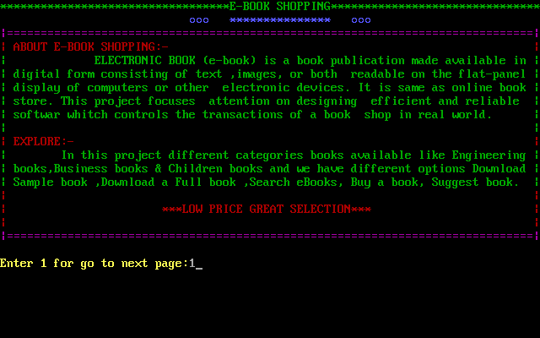

After completion of information it will ask “Enter 1 to go to next page”, if you enter 1 it display ,Different options like Create Account, Login Account .. etc.

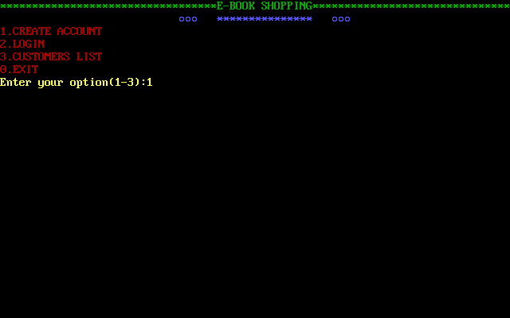

In this options, first option is the Create a new Account in E-Book Shopping. Select it and create an account. It’s out- put is shown in below.

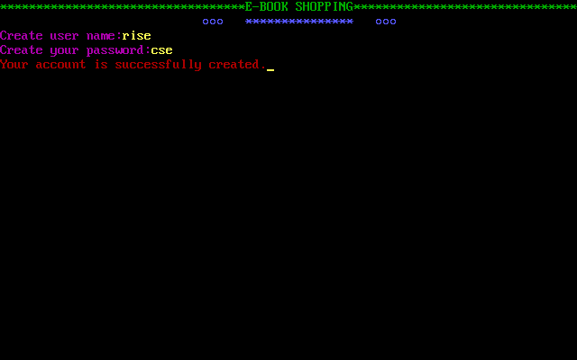

After creating your account then go for login to your account for that select option two (2) , Enter your user name and password.

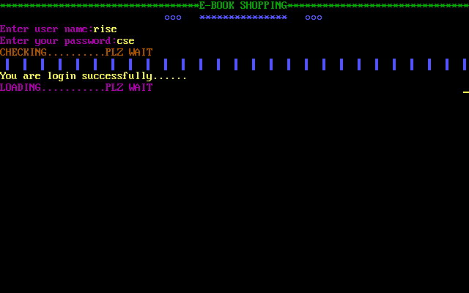

After login it Show different options , has shown in figure.

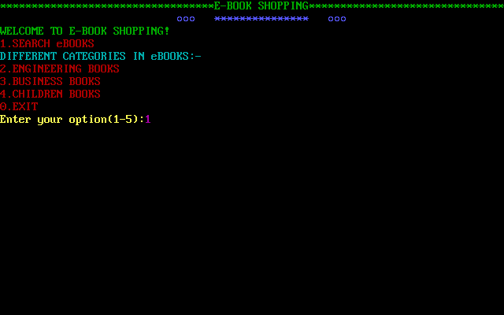

Select option one for search ebooks, after selection of one it ask’s enter book name for searching. If the book is present ebooks it display’s book details and some other options like download, buy and suggest a book.

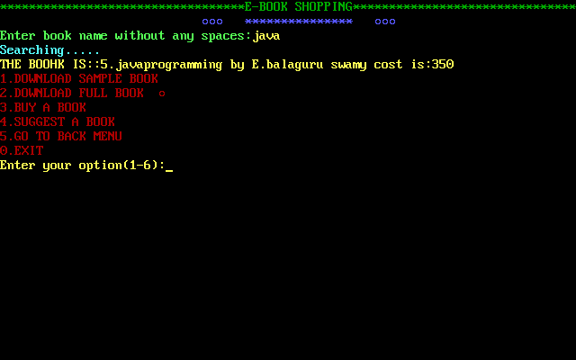

In Search books you entered book is not present at that time it display’s one message and different options.

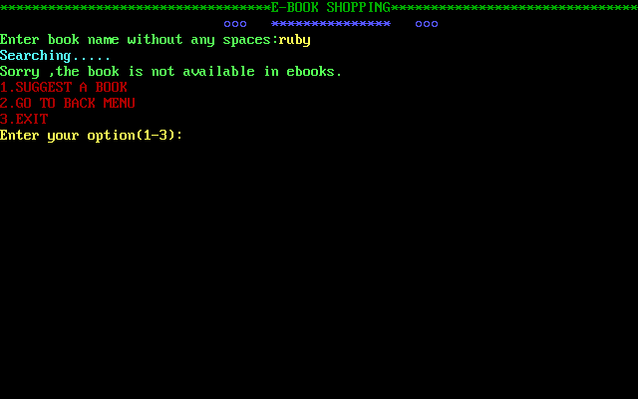

Select option two for Engineering books, after selection of two it display different branches then select on branch.

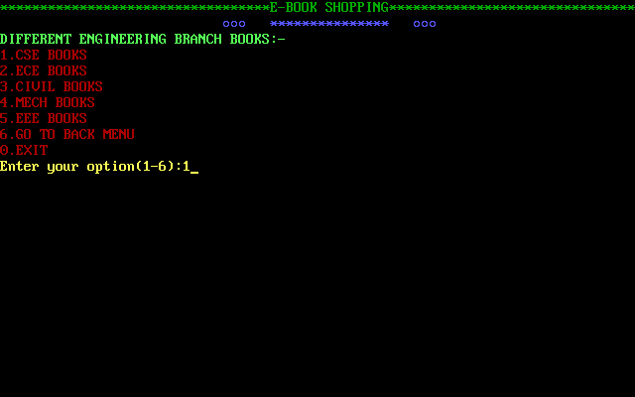

After selection of on branch it display’s collection of books related to you entered branch and some options also displayed.

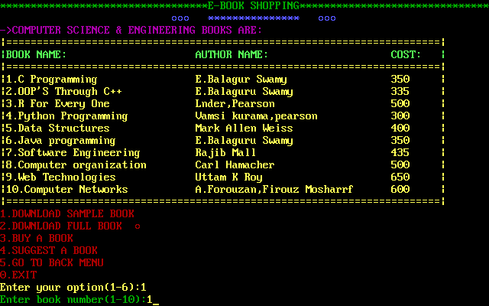

After that select one option and enter book number and it perform some task related to your option. I select one option that is download a sample book and display some path also. It display’s below out-put.

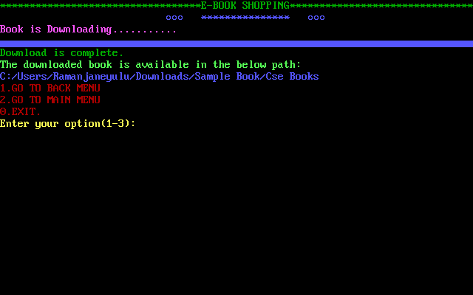

Suppose I select option 3, that is buy a book. After selection of option 3 , it asks enter book number, After it display some options like COD(cash on delivery) and online payment.

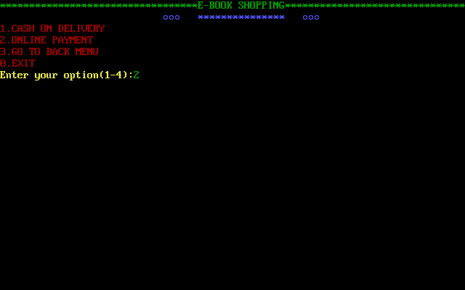

I select option 2, that is online payment. It asks select Credit card or Debit card for online payment. I select Credit card.

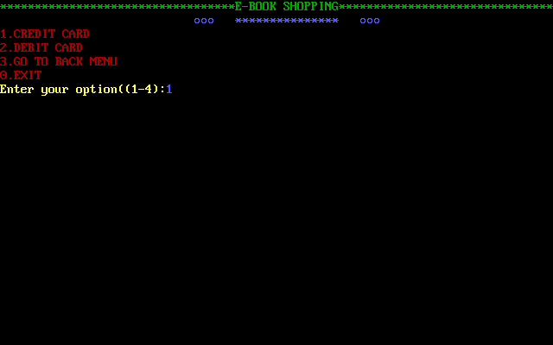

After selection of Credit card, it asks enter your card details like account number validity date and cvv number …etc.

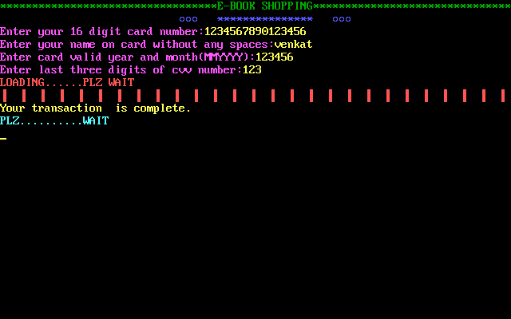

After that it asks your details like your name, phone number and Address. Finally, the order is successfully placed in e-books. 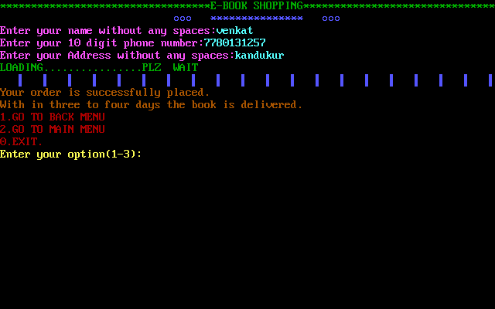

And finally, you are exit from the e-book shopping “enter 0 (ZERO) “.

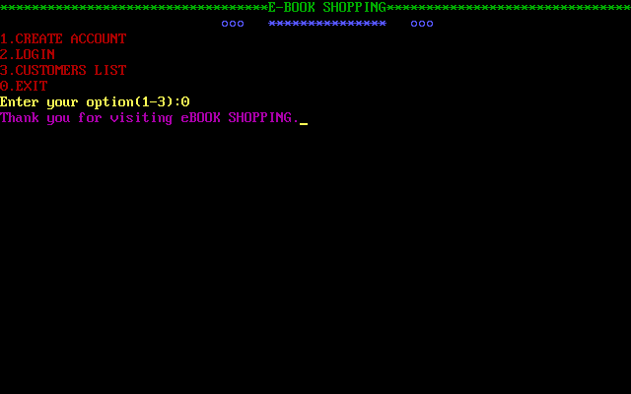

Follow these steps or options, easily down or buy books in e-book shopping.

**************LOW PRICE AND GREAT SELECTION***************